**VIVEKANAND EDUCATION SOCIETY’S INSTITUTE OF TECHNOLOGY**

**Department of Computer Engineering**



Project Report on

Cyberbully and Fake Account Detection in Social Media

In partial fulfillment of the Fourth Year, Bachelor of Engineering (B.E.) Degree in Computer Engineering at the University of Mumbai Academic Year 2020-21

**Submitted by**

Jayesh Samtani (D17 - A , Roll no - 57 )

Sagar Sidhwa (D17 - A , Roll no - 62 )

Somesh Tiwari (D17 - A , Roll no - 71 )

Riya Wadhwani (D17 - A , Roll no - 74 )

**Project Mentor**

Mr. Richard Joseph

(2020-21)

**VIVEKANAND EDUCATION SOCIETY’S INSTITUTE OF TECHNOLOGY**

**Department of Computer Engineering**



**Certificate**

This is to certify that ***Jayesh Samtani,Sagar Sidhwa, Somesh Tiwari, Riya Wadhwani*** of Fourth Year Computer Engineering studying under the University of Mumbai have satisfactorily completed the project on “***CYBERBULLY AND FAKE ACCOUNT DETECTION IN SOCIAL MEDIA*** ” as a part of their coursework of PROJECT-II for Semester-VIII under the guidance of their mentor ***Prof. Richard Joseph*** in the year 2020-21.

This project report entitled “***Cyberbully and Fake Account Detection in Social Media***” by ***Jayesh Samtani, Sagar Sidhwa, Somesh Tiwari, Riya Wadhwani*** is approved for the degree of ***Bachelor of Engineering (B.E.) Degree in Computer Engineering at the University of Mumbai.***

|  |  |
| --- | --- |
| Programme Outcomes | Grade |
| PO1,PO2,PO3,PO4,PO5,PO6,PO7,PO8, PO9, PO10, PO11, PO12,PSO1, PSO2 |  |

Date: 15 May 2021

Project Guide:

------------------------------------------

**Project Report Approval**

**For**

**B. E (Computer Engineering)**

This project report entitled “***Cyberbully and Fake Account Detection in Social Media***” by ***Jayesh Samtani, Sagar Sidhwa, Somesh Tiwari, Riya Wadhwani*** is approved for the degree of ***Bachelor of Engineering (B.E.) Degree in Computer Engineering at the University of Mumbai.***

Internal Examiner

---------------------------------------------

External Examiner

---------------------------------------------

Head of the Department

-----------------------------------------------

Principal

-----------------------------------------------

Date: 15 May 2021

Place:

**Declaration**

We declare that this written submission represents our ideas in our own words and where others' ideas or words have been included, we have adequately cited and referenced the original sources. We also declare that we have adhered to all principles of academic honesty and integrity and have not misrepresented or fabricated or falsified any idea/data/fact/source in our submission. We understand that any violation of the above will be cause for disciplinary action by the Institute and can also evoke penal action from the sources which have thus not been properly cited or from whom proper permission has not been taken when needed.

|  |  |
| --- | --- |
| -----------------------------------------    -----------------------------------------  (Jayesh Samtani D17A-57) | -----------------------------------------    -----------------------------------------  (Sagar Sidhwa D17A-62) |
| -----------------------------------------    -----------------------------------------  (Somesh Tiwari D17A-71) | -----------------------------------------    -----------------------------------------  (Riya Wadhwani D17A-74) |

Date: 15 May 2021

**ACKNOWLEDGEMENT**

We are thankful to our college Vivekanand Education Society’s Institute of Technology for considering our project and extending help at all stages needed during our work of collecting information regarding the project.

It gives us immense pleasure to express our deep and sincere gratitude to Assistant Professor **Mrs. Priya R.L** (Project Guide) for her kind help and valuable advice during the development of project synopsis and for her guidance and suggestions.

We are deeply indebted to Head of the Computer Department **Dr.(Mrs.) Nupur Giri** and our Principal **Dr. (Mrs.) J.M. Nair ,** for giving us this valuable opportunity to do this project.

We express our hearty thanks to them for their assistance without which it would have been difficult in finishing this project synopsis and project review successfully.

We convey our deep sense of gratitude to all teaching and non-teaching staff for their constant encouragement, support and selfless help throughout the project work. It is a great pleasure to acknowledge the help and suggestion, which we received from the Department of Computer Engineering.

We wish to express our profound thanks to all those who helped us in gathering information about the project. Our families too have provided moral support and encouragement several times.

**Computer Engineering Department**

**COURSE OUTCOMES FOR B.E PROJECT**

Learners will be to,

|  |  |
| --- | --- |
| **Course Outcome** | **Description of the Course Outcome** |
| CO 1 | Able to apply the relevant engineering concepts, knowledge and skills towards the project. |
| CO2 | Able to identify, formulate and interpret the various relevant research papers and to determine the problem. |
| CO 3 | Able to apply the engineering concepts towards designing solutions for the problem. |
| CO 4 | Able to interpret the data and datasets to be utilized. |
| CO 5 | Able to create, select and apply appropriate technologies, techniques, resources and tools for the project. |
| CO 6 | Able to apply ethical, professional policies and principles towards societal, environmental, safety and cultural benefit. |
| CO 7 | Able to function effectively as an individual, and as a member of a team, allocating roles with clear lines of responsibility and accountability. |
| CO 8 | Able to write effective reports, design documents and make effective presentations. |
| CO 9 | Able to apply engineering and management principles to the project as a team member. |
| CO 10 | Able to apply the project domain knowledge to sharpen one’s competency. |
| CO 11 | Able to develop professional, presentational, balanced and structured approach towards project development. |
| CO 12 | Able to adopt skills, languages, environment and platforms for creating innovative solutions for the project. |

**Abstract**

Enhancement in the technology trend of using social networking is increasing day by day as of now there are more than 50 crores active users are using different social media platforms for the interaction which had affected their life so just like a coin has two face in a similar way misuse of these platforms is going which cause the the rapid rise of cybercrime and exploitation eg harassing someone by sending malicious messages, spreading abusive messages through fake accounts on social media etc.. In this new era insulting a person physically or emotionally is done by cyberbullying and by using fake accounts, so as a preventive measure to ensure the above things should not happen there is a need of detecting cyberbullying and the fake accounts. In our study to stop cyberbullying and fake accounts we'll use different Machine Learning algorithms for detecting the cybercrime and fake accounts so as to report these issues to the system immediately and to stop the crimes to increase in future and develop a secure online environment.

INDEX

|  |  |  |
| --- | --- | --- |
| **Chapter No** | **Title** | **Page No.** |
| **1** | **Introduction** | **13-16** |
|  | 1.1 Introduction | 13 |
|  | 1.2 Motivation | 14 |
|  | 1.3 Problem Definition | 14 |
|  | 1.4 Existing Systems | 15 |
|  | 1.5 Lacuna of the existing systems | 15 |
|  | 1.6 Relevance of the Project | 15 |
| **2** | **Literature Survey** | **17-21** |
|  | A. Brief Overview of Literature Survey | 17 |
|  | B. Related Works | 17 |
|  | 2.1 Research Papers Referred ( Mentioned in IEEE format )  a. Abstract of the research paper ( in your own word)  b. Inference drawn | 17 |
|  | 2.2. Inference drawn | 20 |
| **3** | **Requirement Gathering for the Proposed System** | **22-23** |
|  | 3.1 Introduction to requirement gathering | 22 |
|  | 3.2 Functional Requirements | 23 |
|  | 3.3. Non-Functional Requirements | 23 |
|  | 3.4.Hardware, Software , Technology and tools utilized | 23 |
|  | 3.5. Constraints | 23 |
| **4** | **Proposed Design** | **24-30** |
|  | 4.1 Block diagram representation of the system | 24 |
|  | 4.2 Modular design of the system | 25 |
|  | 4.3 Detailed Design (DFD - level 0,1,2, State Transition Diagram, ER Diagram, Use case diagram) | 26 |
|  | a.DFD - Level 0,1,2 | 26 |
|  | c. Use Case diagram | 27 |
|  | d. ER Diagram | 28 |
|  | 4.4. Project Scheduling & Tracking using Timeline / Gnatt Chart | 30 |
| **5** | **Implementation of the Proposed System** | **31-34** |
|  | 5.1. Methodology employed for development | 31 |
|  | 5.2 Algorithms and flowcharts for the respective modules developed | 32 |
|  | 5.3 Datasets source and utilization | 34 |
| **6** | **Testing of the Proposed System** | **35-38** |
|  | 6.1 . Introduction to testing | 35 |
|  | 6.2. Types of tests Considered | 35 |
|  | 6.3 Various test case scenarios considered | 38 |
|  | 6.4. Inference drawn from the test cases | 38 |
| **7** | **Results and Discussions** | **39-49** |
|  | 7.1. Screenshots of User Interface (UI) for the respective module | 39 |
|  | 7.2. Performance Evaluation measures | 43 |
|  | 7.3. Input Parameters / Features considered | 45 |
|  | 7.4. Graphical and statistical output | 47 |
|  | 7.5. Comparison of results with existing systems | 49 |
|  | 7.6. Inference drawn | 49 |
| **8** | **Conclusion** | **50-51** |
|  | 8.1 Limitations | 50 |
|  | 8.2 Conclusion | 50 |
|  | 8.3 Future Scope | 50 |
| **9** | **References** | **52** |
| **10** | **Appendix** | **53** |



**Table of Figures**

|  |  |  |
| --- | --- | --- |
| **Sr No.** | **Title** | **Page No** |
| **1** | Graph showing the increase in the rate of CyberBullying in the recent years | 13 |
| **2** | Graph showing the increase in the number of fake accounts | 14 |
| **3** | Rumor detection Results(R: Rumor, N: Non-Rumor) | 20 |
| **4** | Block Diagram | 24 |
| **5** | Modular Design for Cyberbully and fake account detection | 25 |
| **6** | DFD Level-0 Diagram | 26 |
| **7** | DFD Level-1 Diagram | 26 |
| **8** | DFD Level-2 Diagram | 27 |
| **9** | Use Case Diagram | 28 |
| **10** | ER Diagram | 29 |
| **11** | Task Usage Of Project | 30 |
| **12** | Gantt Chart | 30 |
| **13** | SVM Model | 34 |
| **14** | Integration Testing | 37 |
| **15** | Home Page | 39 |
| **16** | Login Page | 39 |
| **17** | Register Page | 40 |
| **18** | New Post Page | 40 |
| **19** | Details Page | 41 |
| **20** | Admin Page | 41 |
| **21** | Post Details Page | 42 |
| **22** | Fake Account Page | 43 |
| **23** | Comparison of F1 Score of the different Algorithm in graph form | 44 |
| **24** | Cyberbully Dataset | 46 |
| **25** | Fake Account Dataset | 47 |
| **26** | Exploratory Data Analysis of comments based on different categories | 48 |
| **27** | Comparison of F1 Score of the different Algorithms | 48 |
| **28** | Accuracy Comparison For Fake Account | 49 |
| **29** | IEEE Paper | 53 |
| **30** | ICAST Conference Certificate | 56 |
| **31** | Plagiarism Report | 59 |
| **32** | Project Review Sheet | 61 |

**CHAPTER – 1**

**INTRODUCTION**

**1.1 Introduction**

Social networking sites have connected us to different parts of the world. However, people are finding illegal and unethical ways to use these communities. We see that people, especially teens and young adults, are finding new ways to bully one another over the Internet. Close to 25% of parents in a study conducted by Symantec reported that, to their knowledge, their child has been involved in a cyberbullying incident.

Other than cyberbullying, Spreading False information is increasingly at a rapid pace. The number of users in social media is increasing exponentially. Instagram has recently gained immense popularity among social media users.

The major source of the fake news are the fake accounts.Business organizations that invest a huge Sum of money on social media influencers must know whether the following gained by that account is organic or not. Hence there is a huge need for the detection of these fake accounts.

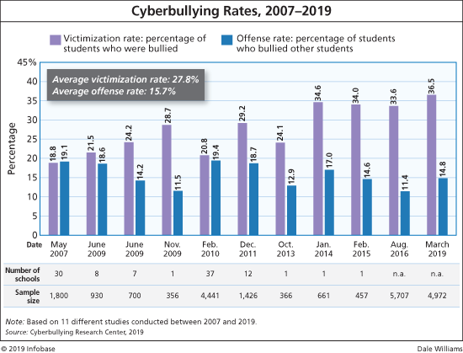

**Fig 1.1.1-Graph showing the increase in the rate of CyberBullying in the recent years**

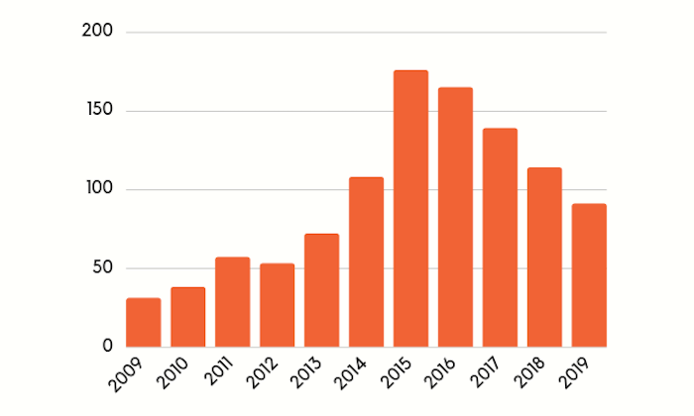

**Fig 1.1.2-Graph showing the increase in the number of fake accounts**

**1.2 Motivation**

The use of social networks such as Facebook, Twitter, Google+, Instagram, and LinkedIn is on the rise. Individuals and organizations use social networks to express their views, advertise their products, and express future policies of their companies and organizations. By expanding the use of social networks, malicious users seek to violate the privacy of other users and abuse their names and credentials by creating fake accounts, which has become a concern for users. Hence, social networks providers are trying to detect malicious users and fake accounts in order to eliminate them from social networking environments. Creating fake accounts in social networks causes more damage than any other cybercrime .

Removing fake accounts has attracted the attention of many researchers thus, extensive research has been carried out on the identification of fake accounts in social networks. Different approaches are proposed to find fake accounts based on attribute similarity hence this generates an awareness in the field of social technology era to remove cyberbullying and eliminate the fake accounts from social media.

**1.3 Problem Definition**

One of the common issues everyone is facing and it is impacting the people, in which some are long period of sadness, anger, irritability, loss of interest in activities, being restless, anxious and worried, even in some cases they go into depression and take steps to scarify their life.It is unfortunate that there are no special Anti-Cyberbullying Laws in India yet.There are some common types of cyberbullying that is Flaming, Harassment, Denigration, Impersonation, Trickery. So to detect cyberbullying we have to make some software that will detect it and then report it to [www.cybercrime.gov.in](http://www.cybercrime.gov.in/). Similarly, we will detect fake accounts.

**1.4 Existing Systems**

Other systems use the algorithm first which gives the message a value and then based on our pre trained data, it decides if the comment is harsh enough to be transformed or not. If it is indeed harsh, then the system will look through our complex network of users and find how this user talks to people on average and how they talk to the end user on average.

Other systems detect cyberbullying attacks in both English and Arabic languages, including Arabish (or Arabizi). Arabizi is the use of Latin letters in writing Arabic text . Sometimes it is referred to as the Arabic chat alphabet. This system uses ML techniques for feature selection/extraction and classification. In a later stage ML will be used for transliteration from Arabic and Arabizi to English characters.

**1.5 Lacuna of the existing systems**

1] Lack of Security -There is a lack of Security in the existing systems but our system will deal with the proper security provision to the users.

2] No Transparency- As the existing system doesn’t provide the proper transparency in their system as they are not able to deal with the Sharing of their reports to the Cybercrime Department.

3] Costly to Produce Reports - The other systems will cost a lot to generate the reports but the system that we will develop will generate results and reports for free.

**1.6 Relevance of the Project**

Most people who are bullied online are also bullied in person. However, while offline bullying allows one the chance to avoid areas and situations that will put them in direct contact with a bully, cyberbullying offers no such reprieve.

Cyberbullying can follow victims wherever they go, whether they are in a crowd or alone. Cyberbullies can reach their victims, 24 hours a day, 7 days a week, 365 days a year. They often post hurtful content online, anonymously, so that they cannot be traced or stopped.

Given the nature of social media, such content is quick to go viral, and reaches a large audience in the blink of an eye, making it difficult, even impossible, for authorities to delete the harmful content before it wrecks damage.

The all-pervasive nature of cyberbullying, as well as the amount of time it takes to trace cyberbullies, makes the growth of cyberbullying an alarming trend across the globe.

Because cyberbullying is difficult to track, many victims feel helpless and unable to cope with it, especially if the bullying is personal and long-drawn. It is no surprise, therefore, that this form of bullying has been known to trigger depression and anxiety in its victims. In many instances, it has also resulted in victims developing suicidal tendencies.

Hence, social networks providers are trying to detect malicious users and fake accounts in order to eliminate them from social networking environments. Creating fake accounts in social networks causes more damage than any other cybercrime.

**CHAPTER – 2**

**LITERATURE SURVEY**

Inthis chapter we are going to see all the literature surveys associated with our project. We have studied all of the below mentioned papers from which we have drawn some inferences and conclusions. We got to know a lot about the work which we have to do and the way in which we should proceed so that we can get the best classification model that will help to classify the posts on social platforms as toxic, sever_toxic , threat, insult etc. For the fake account also we got to know which are all parameters that we should take into consideration so that the model will give accurate results.

There is really lots of work being done in this field to identify the cyberbully and also the fake account detection in twitter, instagram and facebook is using some techniques to overcome this problem and provide overall good experience to its users.

**2.1 Research Papers Referred**

1. **Fake Twitter accounts: Profile characteristics obtained using an activity-based pattern detection approach[1]:**

**Abstract :** In this paper analysis 62 millions ofpublicly available Twitter user profiles was conducted and a strategy to retroactively identify automatically generated fake profiles was established. As recently as 2010, when the maximum number of Twitter user IDs was estimated to be less than 800 million , it was feasible to crawl over the entire Twitter user ID space. Spam accounts constitute as much as 93% of all new accounts, 68% of which are detected and automatically suspended or deleted by Twitter. To overcome these issues, they performed a Breadth First Search (BFS) over a given set of seed users. As the social graph is crawled, and eventually the user profiles for these IDs are acquired. This ensures that all user profile requests we make to Twitter include only valid Twitter user IDs.

**Inference :** From this paper we got the information about the fake account dataset quantity, because due to the low number of false positives of fake account data accuracy of model decreased even if the twitter profile database was approx 60 million.

1. **Detection of Behavior Patterns through Social Networks likeTwitter, using Data Mining techniques as a method to detect Cyberbullying[2] :**

# Abstract : Social networks such as Twitter or Facebook have revolutionized the communication mechanism between human beings, but have also generated a negative impact due to inappropriate use, this fact is perpetuated by cybercriminals to hurt other people psychologically, these bad practices are called cyberbullying. This research focuses on the detection and analysis of cyberbullying on pages and with pejorative terms in Spanish, taking advantage of the power of classification of feelings through specialized tools. For the detection of cyberbullying, first the efficiency of classification of each tool is measured, through a set of pejorative terms commonly used to hurt other people.

# Inference : In the analysis stage we use data mining techniques to generate a dictionary of pejorative terms that are related to cyberbullying and thus be able to generate behavior patterns of these terms. And in this way provide better tools so that psychology specialists can optimize their work. The results show which platform is more flexible, and also shows which is best suited to the search of incidences of cyberbullying on Twitter.

1. **Classification of Cyberbullying in Facebook Using Selenium and SVM[3]:**

**Abstract :** Cyberbullying is one of the emerging problems over the past few years especially to teenagers. Approximately 24% of teens go online constantly, facilitated by the widespread availability of smartphones. Almost 21% of teens said the main reason they checked social media always was to make sure nobody was saying mean or bad things to them. Cyberbullying related Facebook posts were harvested by a customized web scraper tool.

**Inference :** In this paper facebook data were used for classification using Support Vector Machines (SVM) models. A total of 2263 data was used for training data, Facebook posts. Based on these posts, the study achieved the precision of 88% and the recall is 87%. So it is quite a good algorithm for cyberbully detection.

1. **Identifying Fake News from the Variables that Governs the Spread of Fake News[4]:**

**Abstract :** Several researchers have attempted to investigate the processes that govern and support the spread of fake news. This paper collates and identifies these variables. This paper then categorised these variables based on three key players that are involved in the process: Users, Content, and Social Networks. The authors conducted an extensive review of the literature and a reflection on the key variables that are involved in the process. The paper has identified a total of twenty-seven variables. Then the paper presents a series of tasks to mitigate or eliminate these variables in a holistic process that could be automated to reduce or eliminate fake news propagation. Finally, the paper suggests further research into testing the method in lab conditions.

**Inference:** In paper has reviewed a variety of variables identified by researchers in the field of understanding the factors that influence fake news. The variables show a significant overlap in views but also concentration on different players. As such, the paper collated all these variables and redistributed them based on the key players. This has helped build a holistic and bigger picture of the environment in which Fake News thrives. The variables identified pinpointed some areas where one can see how different social media platforms have attempted to combat fake news and failed.

1. **Detecting Rumors from Microblogs with Recurrent Neural Networks[5]:**

**Abstract** : Microblogging platforms are an ideal place for spreading rumors and automatically debunking rumors is a crucial problem. To detect rumors, existing approaches have relied on hand-crafted features for employing machine learning algorithms that require daunting manual effort. Upon facing a dubious claim, people dispute its truthfulness by posting various cues over time, which generates long-distance dependencies of evidence. This paper presents a novel method that learns continuous representations of microblog events for identifying rumors. The proposed model is based on recurrent neural networks (RNN) for learning the hidden representations that capture the variation of contextual information of relevant posts over time. Experimental results on datasets from two real-world microblog platforms demonstrate that (1) the RNN method outperforms state-of-the-art rumor detection models that use hand-crafted features; (2) performance of the RNN-based algorithm is further improved via sophisticated recurrent units and extra hidden layers; (3) RNN-based method detects rumors more quickly and accurately than existing techniques, including the leading online rumor debunking services.

**Inference :** In this research, we propose a deep learning framework for rumor debunking. Our method learns RNN models by utilizing the variation of aggregated information across different time intervals related to each event. We empirically evaluate our RNN-based method with three widely used recurrent units, tanh, LSTM and GRU, which perform significantly better than the state-of-the-art.

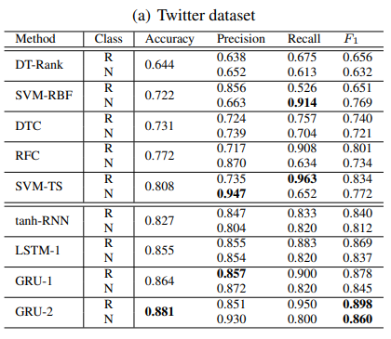

**Fig 2.1.5 Rumor detection Results(R: Rumor, N: Non-Rumor)**

1. **Automatic detection of cyberbullying in social media text[6]:**

**Abstract** : The focus of this paper is on automatic cyberbullying detection in social media text by modelling posts written by bullies, victims, and bystanders of online bullying. We describe the collection and fine grained annotation of a cyberbullying corpus for English and Dutch and perform a series of binary classification experiments to determine the feasibility of automatic cyberbullying detection. We make use of linear support vector machines exploiting a rich feature set and investigate which information sources contribute the most for the task. Experiments on a hold-out test set reveal promising results for the detection of cyberbullying-related posts. After optimisation of the hyperparameters, the classifier yields an F1 score of 64% and 61% for English and Dutch respectively, and considerably outperforms baseline systems .

**Inference :**A set of binary classification experiments were conducted to explore the feasibility of automatic cyberbullying detection on social media. In addition, we sought to determine which information sources contribute most to the task. Two classifiers were trained on an English and Dutch ASKfm corpus and evaluated on a hold-out test of the same genre. Overview of the most related cyberbullying detection approaches.After feature and hyperparameter optimisation of our models, a maximum F1 score of 64.32% and 58.72% was obtained for English and Dutch.

**2.2. Inference drawn**

The very first point is most of them haven't used the NLP for their classification of the text they just trained it on their model and founded the results and the second point we got is that they had trained it only one models and different projects in the literature have different models with varying accuracy, So, to overcome the first point we had used the NLP for cleaning and for the second problem we will train and test our prediction on the different models (for e.g Random Forest,Logistic Regression , Decision Tree etc.) and find the best models with best accuracy for the toxicity type, so that each and every type of offensive language will be identified and classified accurately.

Overall Inference from all the above papers is that the use of ML algorithm varies with different types of dataset so we will have to use some of the algorithms which are used as per the literature survey, for the testing and after comparison we can use the best model based on countvectorizer and F1 score value. From the above literature survey we got to know that the Random forest and SVM is giving best results for classification, so we will focus more on these algorithms only so that we’ll save a lot of time.

**CHAPTER – 3**

**REQUIREMENT GATHERING**

**3.1 Introduction to requirement gathering**

The applied technique consists of the following points namely re-processing, mining required parameters, and a separate phase is listed below.

1] The very first part is to convert the jumbled or the impure information into pure information and to convert the strings into small tokens this process is known as tokenization.

2] In this part, we will convert the pure information collected from the first part to the smaller format that means converting the capital letters to small letters.

3] This is a very crucial part of this technique where we remove certain special characters such as ‘\b’ or ‘\n’ since we need meaningful characters and such characters don't provide any meaningful content.

4] The next part is to convert this data into Machine learning format so as to give input to our Models.

5] The final part of this technique is to provide input data to our machine learning algorithm so as to classify the data as toxic, sever_toxic, identity_hate, threat, obscene, insult.

6] The accuracy of different algorithms will be Compared to get the best possible result. For fake profile detection, this paper proposes the detection process starts with the selection of the profile that needs to be tested.

7] After selection of the profile the suitable attributes ie., features are selected on which the classification algorithm is being implemented, the attributes extracted are passed to the trained classifier. Different Classifier algorithms such as Gradient Booster, random forest Decision trees, Support Vector Machine, and Neural Networks such as RNN and CNN can be used. The model generated by the learning algorithm should both fit the input data correctly and also correctly predict the class labels of the learning algorithm to build the model with good generality capability.

8] The complete dataset of the fake account is used for the training purpose this data after preprocessing is fed to the different machine learning algorithms and the accuracy is compared and according to the results the Random Forest has given us the best results and for the testing purpose, the live data is fetched from the Twitter.

**3.2 Functional Requirements**

* **Social Media-**

The government uses social media technologies to extract opinion from people regarding a specific issue , these social media technologies have now been seen as the most extensively used platforms to conduct electronic participation activities. According to smallbiztrends.com, Facebook, Twitter and Instagram are one of the famous social networking sites that a lot of people are using including establishments and organizations .With high online activity using these sites, teens can be a victim or a perpetrator of cyberbullying

* User authentication module should detect and reject malicious authentication attempts.
* The system should decide whether a suspicious content should be checked for malicious

behaviour or for fake identity or activity.

* Each time a malicious behaviour is detected, an account should be added in the appropriate

malicious behaviour reputation list.

* **Admin-** It can view and block all the malicious accounts

**3.3 Non-Functional Requirements**

* **Availability -** The system is available all the time, no time constraint

**3.4 Hardware, Software , Technology and tools utilized**

* Intel Pentium Processor
* RAM > 4GB
* Django
* Machine Learning Algorithms
* Anaconda

**3.5 Constraints**

* Continuous Internet Connection
* Risk Management
* System Failure

**CHAPTER – 4**

**PROPOSED DESIGN**

This chapter describes the block diagram, modular design and detailed design of the system. Detailed design consists of a data flow diagram(DFD level-0,1,2) , State transition diagram, ER diagram and Use Case Diagram.Project scheduling and tracking using timeline/ gantt chart is also mentioned in this chapter. These all diagrams and designs give us the overall working of the project.

**4.1 Block diagram of the system**

A block diagram is a specialized, high-level flowchart. It is used to design new systems or to describe and improve existing ones. Its structure provides a high-level overview of major system components, key process participants, and important working relationships.

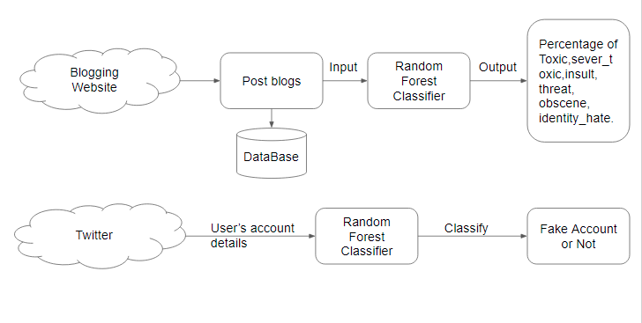

**Fig 4.1.1 Block Diagram**

The user will first login in to our portal with his/her credentials or can sign up on our portal for new registration. The portal can work as a simple blog where users can post their views and can read other people's views.on posting the views it will undergo certain machine learning algorithm processing where it will determine whether the following post is cyberbullying or not . If found that the post is vulnerable the system will further check that if the account is fake or not.if found fake it will block the account and if the account is not fake the system will report the tweet.

**4.2 Modular design of the system**

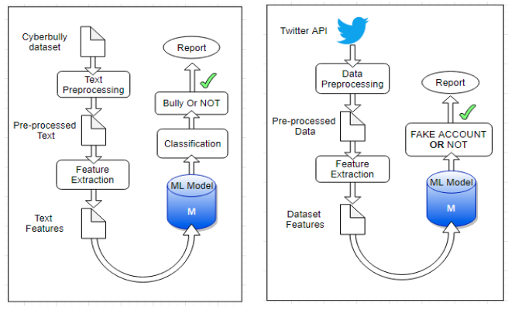

**Fig 4.2.1 Modular Design for Cyberbully and fake account detection**

As we can see here initially we have taken dataset for cyberbully and did some preprocessing(like tokenization, lowering text, then stop word removal) , after this we have extracted the features like we have separated the all the categories of text and then created balanced training and testing dataset so that model will not be overfit.after this we trained different models like (Logistic Regression, SVM, Random Forest, KNNB, BernoulliNB, Multinomial DB).Then we created a TFIDF Vectorizer and calculated F1 score of each model and from that we selected RandomForest classifier is best for each type of comment type. And then we tested and finally we did Pickling for trained RandomForest models for all categories, so that we can easily use those models.

**4.3 Detailed Design (DFD - level 0,1,2, State Transition Diagram, ER Diagram, Use case diagram)**

1. **Data Flow Diagram**

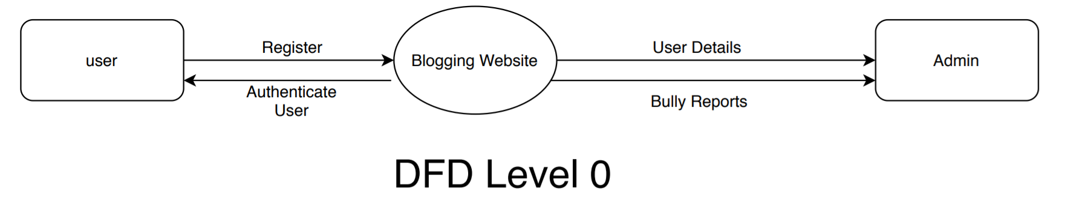

**Fig 4.3.1 DFD Level-0 Diagram**

As shown above the DFD Level-0 diagram which shows that the user first needs to register to the portal then the user details will be forwarded to the admin where if the user posts something abusive at the website then the bully reports will be sended to the admin and the admin can authenticate the user**.**

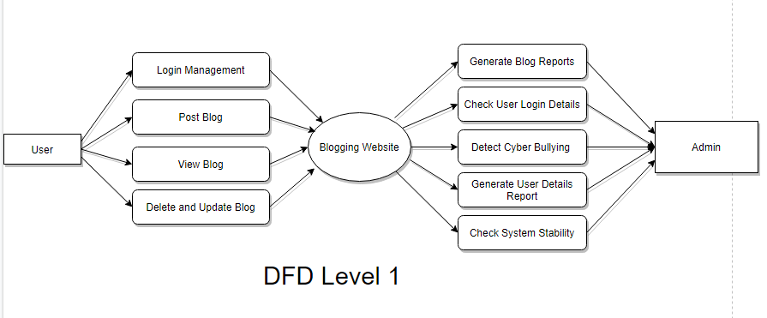

**Fig 4.3.2 DFD Level-1 Diagram**

In the DFD Level-1 Figure the user can perform the functionality like it can do login,post blog,view its blog and delete or update its blog on the blogging website and from the admin side. It can generate blog reports ,check user login details ,detect cyberbullying, generate user details reports,check system stability.

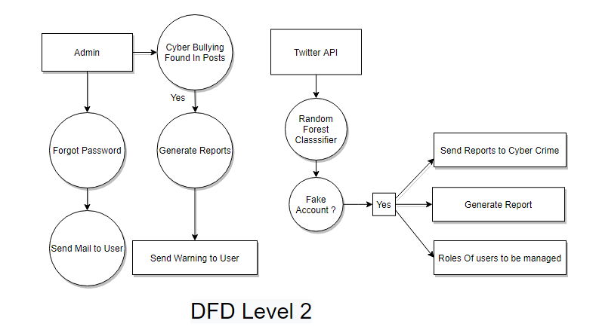

**Fig 4.3.3 DFD Level-2 Diagram**

In DFD Level 2 Diagram, as shown above the flow is like User will Register and then he/she will log into the blogging Website where he/she will post some blogs and can view other users blogs also.If he/she has posted some offensive or bully content then that will be detected and then Account verification will be also done if the account is fake or not valid then a report will be generated and that will be sent to the Cyber Crime and Users Account will be blocked.

1. **USE CASE DIAGRAM**

A use case diagram is a dynamic or behavior diagram in UML. Use case diagrams model the functionality of a system using actors and use cases. ... In this context, a "system" is something being developed or operated, such as a web site. The "actors" are people or entities operating under defined roles within the system.

This is the sample Use Case Diagram representing the Cyberbullying and fake Account detection model ,If we look into diagram we can see the Use Cases as Follows:

Manage Account, Manage Blog, Add Post, View Blogs,Manage application,Manage Users,Account and Blog. We have two Actors as we can see in the diagram User and Admin.

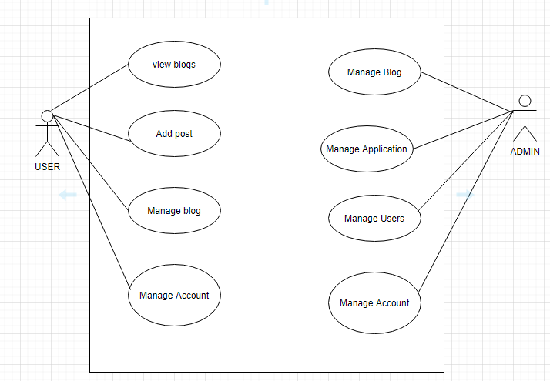

**Fig 4.3.4 Use Case Diagram**

1. **ER Diagram**

An Entity Relationship (ER) Diagram is a type of flowchart that illustrates how “entities” such as people, objects or concepts relate to each other within a system. ER Diagrams are most often used to design or debug relational databases in the fields of software engineering, business information systems, education and research. Also known as ERDs or ER Models, they use a defined set of symbols such as rectangles, diamonds, ovals and connecting lines to depict the interconnectedness of entities, relationships and their attributes.

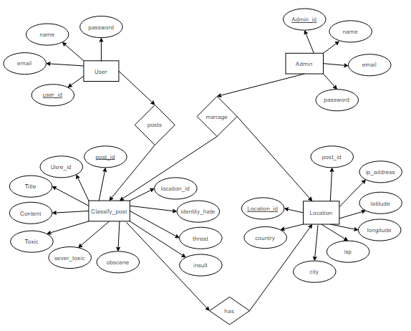

**Fig 4.3.5 ER Diagram**

As wecan see that there are four tables (user table, clasify_post table, location table and admin table). User table consists of four attributes such as user_id(primary key), name, email and password. Classify posts consist of eleven attributes such as post_id(primary key), user_id(foreign key), title, content, toxic, sever_toxic, obscene, threat, insult, identity_hate and location_id(foreign key). Location table consists of 8 attributes and it shows the location of users with longitude and latitude and Internet Service Provider(ISP).

**4.4 Project Scheduling & Tracking using Timeline / Gantt Chart**

**1.Table**

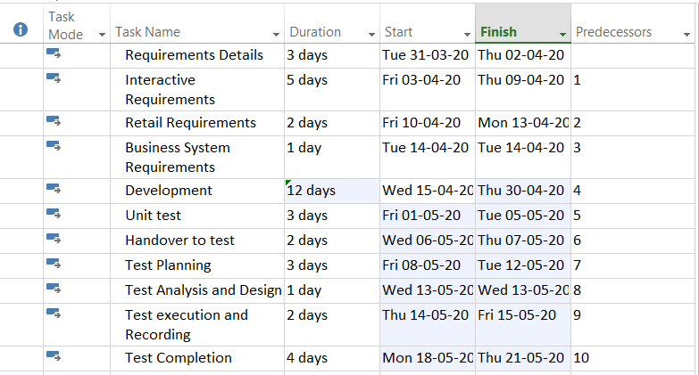

Fig 4.4.1 Task Usage Of Project

**2. Gantt Chart**

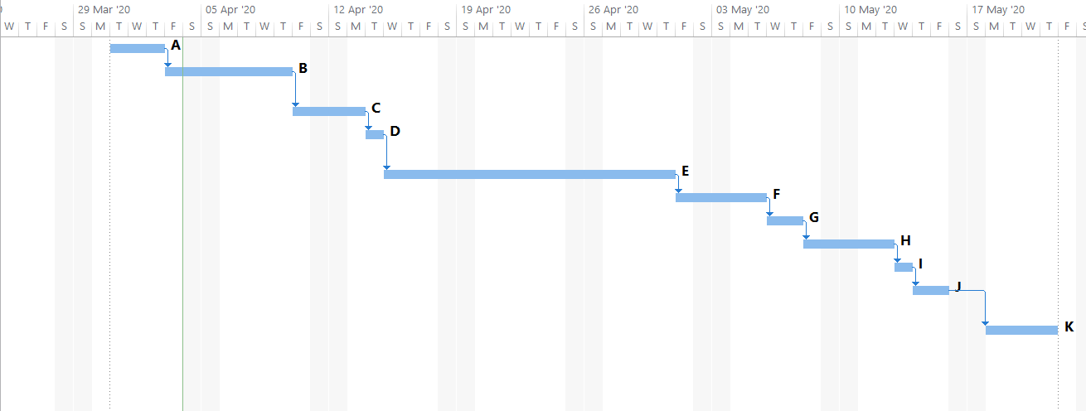

Fig 4.4.2 Gantt Chart

**CHAPTER – 5**

**IMPLEMENTATION OF PROPOSED DESIGN**

**5.1. Methodology employed for development**

The proposed approach contains three main steps namely Preprocessing, features extraction and classification step. In the preprocessing step we clean the data by removing the noise and unnecessary text.

The preprocessing step is done in the following.

**1] Tokenization**: In this part we take the text as sentences or whole paragraphs and then output the entered text as separated words in a list.

**2] Lowering text**: This takes the list of words that got out of the tokenization and then lower all the letters Like: ’THIS IS AWESOME’ is going to be ’this is awesome’.

**3] Stop words and encoding cleaning:** This is an essential part of the preprocessing where we clean the text from those stop words and encoding characters like \n or \t which do not provide meaningful information to the classifiers.

4] The second step of the proposed Model is the features extraction step. In this step the textual data is transformed into a suitable format applicable to feed into machine learning algorithms.

5] The last step in the proposed approach is the classification step where the extracted features are fed into a classification algorithm to train, and test the classifier and hence use it in the prediction phase.We will use classifiers, namely, SVM (Support Vector Machine), Naive Bayes,Random Forest, Decision Tree , Logistic Regression.

6] Accuracy of different algorithms will be Compared to get the best possible result. For the fake profile detection this paper proposes the detection process starts with the selection of the profile that needs to be tested.

7] After selection of the profile the suitable attributes ie., features are selected on which the classification algorithm is being implemented ,the attributes extracted are passed to the trained classifier. Different Classifier algorithms such as Gradient Booster, random forest Decision trees ,Support Vector Machine.

**FOR FAKE PROFILE:**

Each profile (or account) in a social network contains lots of information such as gender, no. of friends, no. of comments, education, work, etc. Some of this information is private and some are public. Since private information is not accessible, we have used only the information that is public to determine the fake profiles in the social network. We have considered this information as features of a profile for the classification of fake and real profiles. The steps that we have followed for the identification of fake profiles are as follows.

1. First, all the features are selected on which the classification algorithm is applied.

2.After proper selection of attributes, the dataset of previously identified fake and real profiles are needed for the training purpose of the classification algorithm.

3.After this data preprocessing is done , in the preprocessing step we clean the data by removing the noise and unnecessary text.

4.After Preprocessing this cleaned data is fed to various machine learning classifiers such as SVM, Decision Trees , Random Forest Gradient Descent,Naive bayes.

5.Accuracy of all these algorithms is compared and the one with best efficiency is selected.

6.For testing real time data is fetched via twitter api is fetched and is given as input to uur machine learning model.

**5.2 Algorithms and flowcharts for the respective modules developed**

**5.2.1 Logistic Regression**

Logistic regression is one of the well-known techniques introduced from the field of statistics by machine learning.Logistic regression is an algorithm that constructs a separate hyper-plane between two datasets utilizing the logistic function. The logistic regression algorithm takes features (inputs) and produces a forecast according to the probability of a class suitable for the input. For instance, if the likelihood is ≥0.5, the instance classification will be a positive class; otherwise, the prediction will be for the other class (negative class) , as given in Equation. logistic regression was used in the implementation of predictive cyberbullying models. hθ (x) = 1 1 + e −θTx , (1) if hθ (x) ≥ 0.5, y = 1 (Positive class) and if hθ (x) ≤ 0.5, y = 0 (Negative class)

**5.2.2 Random Forest algorithm**

The Random Forest Algorithm is composed of different decision trees, each with the same nodes, but using different data that leads to different leaves. It merges the decisions of multiple decision trees in order to find an answer, which represents the average of all these decision trees

The random forest algorithm is a supervised learning model; it uses labeled data to “learn” how to classify unlabeled data. This is the opposite of the K-means Cluster algorithm,which is an unsupervised learning model. The Random Forest Algorithm is used to solve both regression and classification problems, making it a diverse model that is widely used by engineers.

When performing Random Forests based on classification data, you should know that you are often using the Gini index, or the formula used to decide how nodes on a decision tree branch

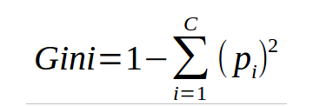.

This formula uses the class and probability to determine the Gini of each branch on a node, determining which of the branches is more likely to occur. Here, *pi* represents the relative frequency of the class you are observing in the dataset and *c* represents the number of classes.

**5.2.3 Naives bayes classifier**

Naives bayes classifiers are a group of machine learning algorithms that all use the Bayes’ Theorem to classify data points. The Bayes’ Theorem is named after Reverend Thomas Bayes, a man who studied probability and binomial distributions in the 18th century. The mathematics behind Naive Bayes The algorithm completely depends upon Bayes theorem since the classifiers simply apply the formula to sets of data. This theorem consists of a formula assessing probabilities of different events occurring. The formula below is the simplest version of it, with only two events — Event A and B. 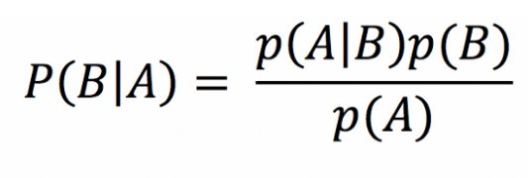

**5.2.4 Support Vector Machine (SVM)**

Support Vector Machine (SVM) is a supervised machine learning classifier widely utilized in text classification . SVM turns the original feature space into a user-defined kernel-based higher-dimensional space and then seeks support vectors for optimizing the distance (margin) between two categories. SVM originally approximates a hyperplane separating the two categories. SVM accordingly selects samples from both categories, which are nearest to the hyperplane, referred to as support vectors.

SVM seeks to efficiently distinguish the two categories (e.g., positive and negative). If the dataset is separable by nonlinear boundaries, specific kernels are implemented in the SVM to turn the function space appropriately. Soft margin is utilized to prevent overfitting by giving less weighting to classification errors along the decision boundaries for a dataset that is not easily separable [101]. In this research, we utilize SVM with a linear kernel for the basis function. Figure 2 shows the SVM classifier implementation for a dataset with two features and two categories where all samples for the training are depicted as circles or stars. Support vectors (referred to as stars) are for each of the two categories from the training samples, meaning that they are nearest to the hyperplane among the other training samples.

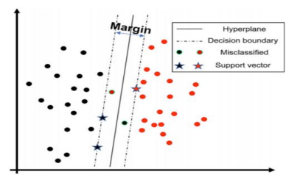

**Fig-5.2.4 SVM Model**

**5.3 Datasets source and utilization**

The dataset used for cyberbullying is obtained from kaggle.

Following are the parameters of the dataset: Text(comment),toxic , server toxic , insult , obscene , threat , identity threat. All these parameters are taken into consideration for the training of our model.

For Fake profile detection we have used a kaggle dataset as well as live data fetched from twitter .

The dataset comprises of following parameter : id , screen_name , statuses_count , friend_count ,

following_count , profile_url , location ,profile_backgroundcolor , favourites , listed_count, language , The parameters taken into consideration are statuses_count , friend_count , following_count, favourites , listed_count,time zone.

The model is tested on live data fetched via twitter api.

**CHAPTER – 6**

**TESTING OF PROPOSED SYSTEM**

**6.1 . Introduction to testing**

**Definition**: A TEST CASE is a set of conditions or variables under which a tester will determine whether a system under test satisfies requirements or works correctly.

The process of developing test cases can also help find problems in the requirements or design of an application.Testing plays an important role in quality assurance for the software. It is a dynamic method for the verification and validation, where the system to be tested is executed and the behavior of the system is observed

**6.2. Types of tests Considered**

**Alpha Testing**

It is the most common type of testing used in the Software industry. The objective of this testing is to identify all possible issues or defects before releasing it into the market or to the user.Alpha Testing is carried out at the end of the software development phase but before the Beta Testing. Still, minor design changes may be made as a result of such testing.Alpha Testing is conducted at the developer’s site. In-house virtual user environments can be created for this type of testing.

**Entry Criteria for Alpha testing:**

* Software requirements document or Business requirements specification
* Test Cases for all the requirements
* Testing Team with good knowledge about the software application
* Test Lab environment setup
* QA Build ready for execution
* Test Management tool for uploading test cases and logging defects
* Traceability Matrix to ensure that each design requirement has at least onetest case that verifies it

**Exit Criteria for Alpha testing**

* All the test cases have been executed and passed.
* All severity issues need to be fixed and closed
* Delivery of Test summary report
* Make sure that no more additional features can be included
* Sign off on Alpha testing

**Black Box Testing**

BLACK BOX TESTING, also known as Behavioral Testing, is a software testing method in which the internal structure/design/implementation of the item being tested is not known to the tester. These tests can be functional or non-functional, though usually functional.This method is named so because the software program, in the eyes of the tester, is like a black box; inside which one cannot see. This method attempts to find errors in the following categories:

* Incorrect or missing functions
* Interface errors
* Errors in data structures or external database access
* Behavior or performance errors
* Initialization and termination errors

**White box testing**

White box testing techniques analyze the internal structures, the used data structures, internal design, code structure and the working of the software rather than just the functionality as in black box testing. It is also called glass box testing or clear box testing or structural testing.

Working process of white box testing:

**1.Input**: Requirements, Functional specifications, design documents, source code.

**2.Processing**: Performing risk analysis for guiding through the entire process.

**3.Proper test planning**: Designing test cases so as to cover the entire code. Execute rinse-repeat until error-free software is reached. Also, the results are communicated.

**Output:** Preparing final report of the entire testing process.

**UNIT TESTING**

Unit testing is a type of software testing where individual units or components of a software are tested. The purpose is to validate that each unit of the software code performs as expected. Unit Testing is done during the development (coding phase) of an application by the developers. Unit Tests isolate a section of code and verify its correctness. A unit may be an individual function, method, procedure, module, or object.

In SDLC, STLC, V Model, Unit testing is the first level of testing done before integration testing. Unit testing is a WhiteBox testing technique that is usually performed by the developer. Though, in a practical world due to time crunch or reluctance of developers to tests, QA engineers also do unit testing.

**INTEGRATION TESTING**

It is a level of software testing where individual units are combined and tested as a group. The purpose of this level of testing is to expose faults in the interaction between integrated units. Test drivers and test stubs are used to assist in Integration Testing.

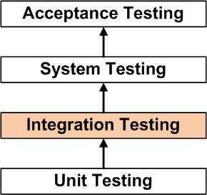

**Fig 6.2.1 Integration Testing**

**SYSTEM TESTING**

System Testing is a level of testing that validates the complete and fully integrated software product. The purpose of a system test is to evaluate the end-to-end system specifications. Usually, the software is only one element of a larger computer-based system. Ultimately, the software is interfaced with other software/hardware systems. System Testing is actually a series of different tests whose sole purpose is to exercise the full computer-based system.

System Testing involves testing the software code for following:

* Testing the fully integrated applications including external peripherals in order to check how components interact with one another and with the system as a whole. This is also called End to End testing scenario.
* Verify thorough testing of every input in the application to check for desired outputs.
* Testing of the user's experience with the application.

**6.3 Various test case scenarios considered**

|  |  |  |
| --- | --- | --- |
| **Type of input** | **Example** | **Observations** |
| 1. Negative sentences | I will not kill you | This sentence has word kill but it is not toxic and has to be categorized as neutral.algorithm need not be heavily dependent on words it has to extract meaning of the sentence |
| 1. Tricky input | I want to kill my time | There is talk about killing someone but it's time not a person or any living creature. so this comment has to be classified as neutral |

**6.4. Inference drawn from the test cases**

We tested our system on various inputs and concluded that if certain inputs give at least 50% of probability on any category it will be categorized as the following type.

On testing we found that if sentences had more than 2 negation words our system does predict correctly but some sentences with no toxicity gives approx as 40% result which is less than 50% but it can be further reduced to around 20%.

**CHAPTER – 7**

**RESULTS AND DISCUSSION**

**7.1. Screenshots of User Interface (UI) for the respective module**

7.1.1 Home Page

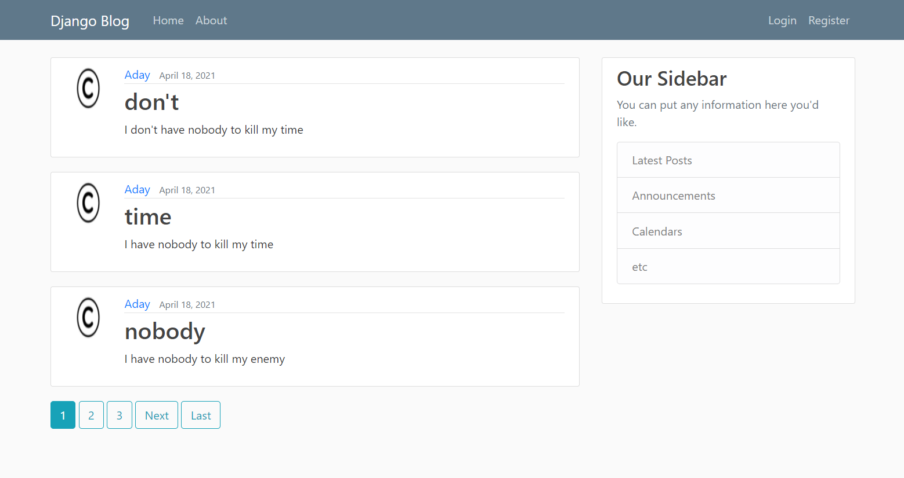

**Fig 7.1.1 Home Page**

7.1.2 Login Page

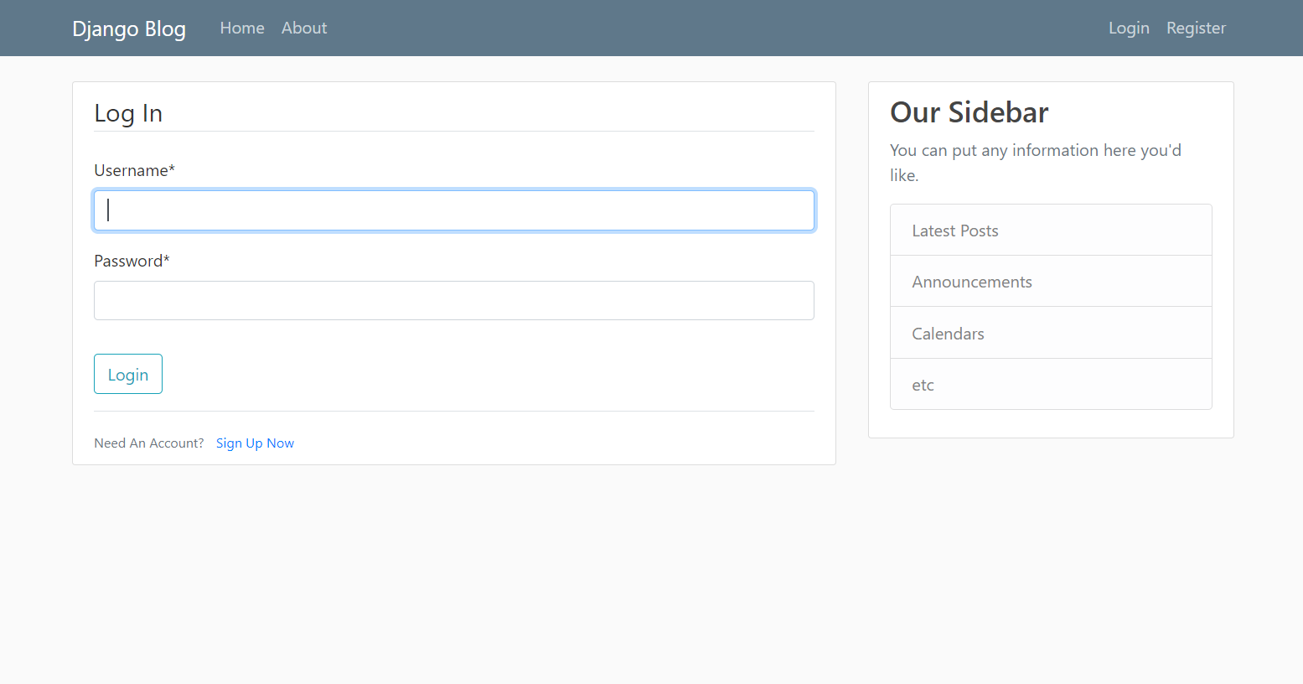

**Fig 7.1.2 Login Page**

7.1.3 Register Page

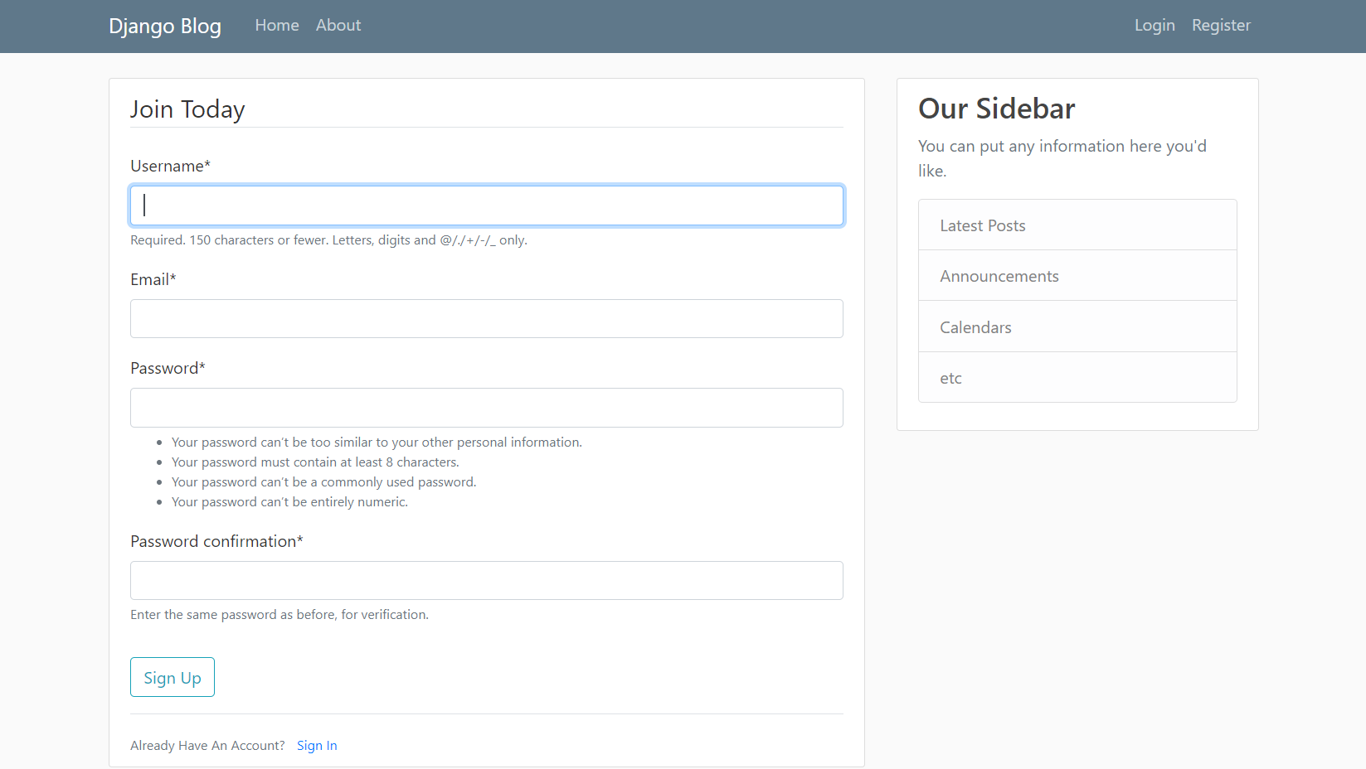

**Fig 7.1.3 Register Page**

7.1.4 New Post Page

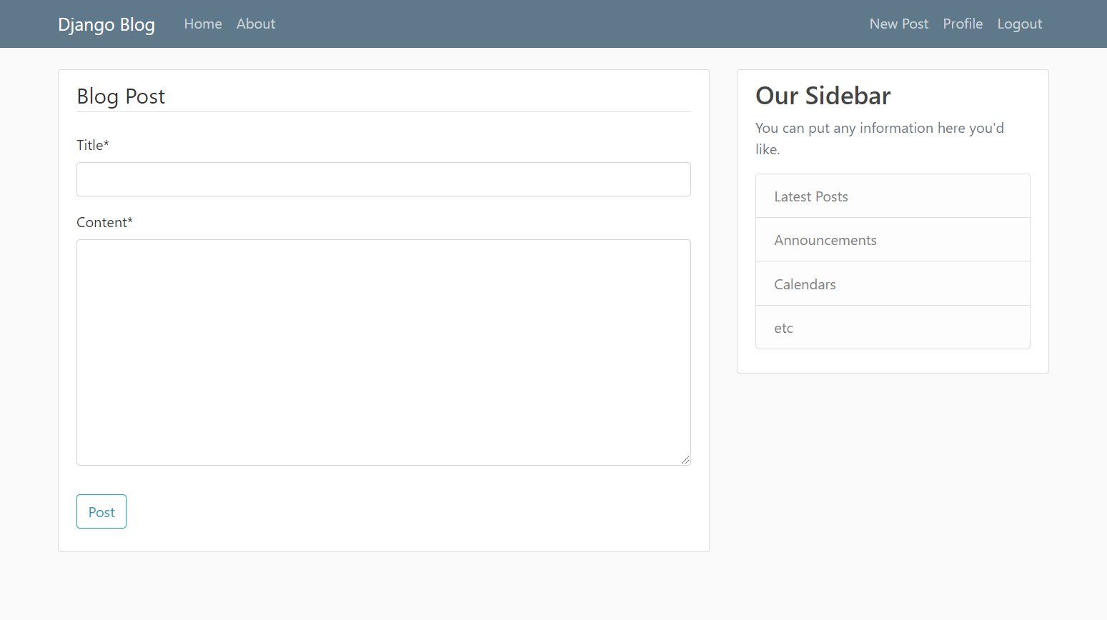

**Fig 7.1.4 New Post Page**

7.1.5 Details Page

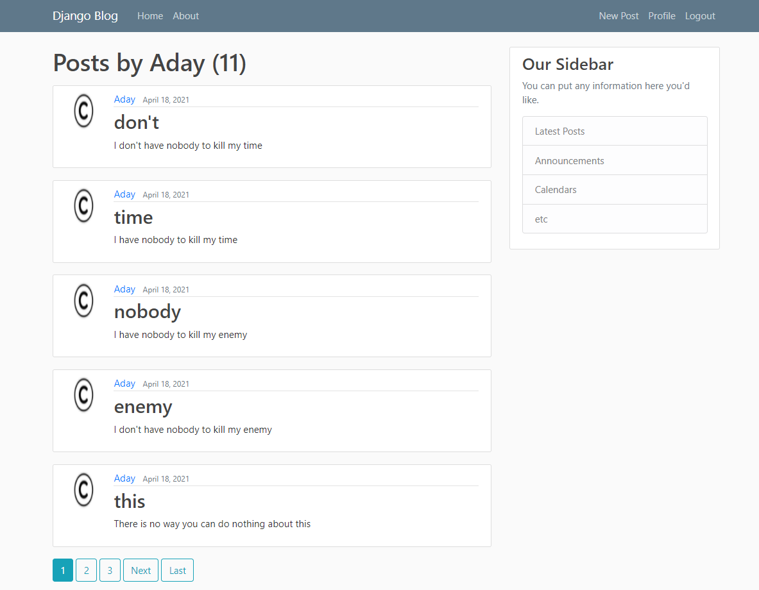

**Fig 7.1.5 Details Page**

7.1.6 Admin Page

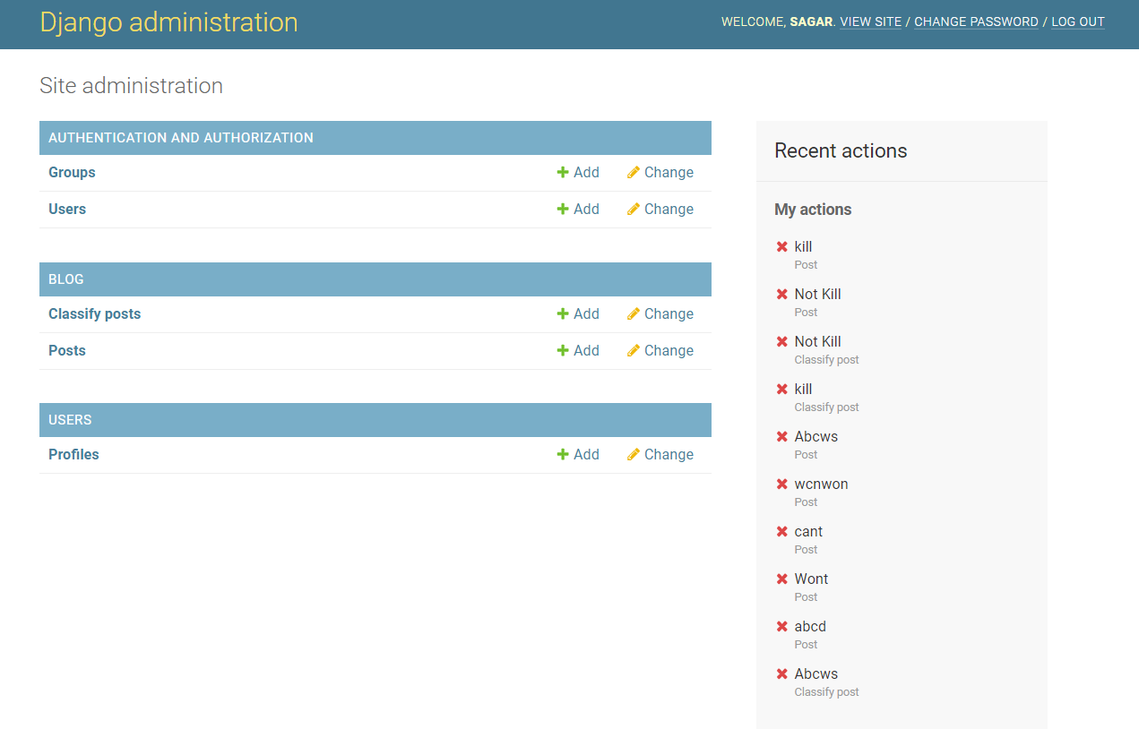

**Fig 7.1.6 Admin Page**

7.1.7 Post Details Page

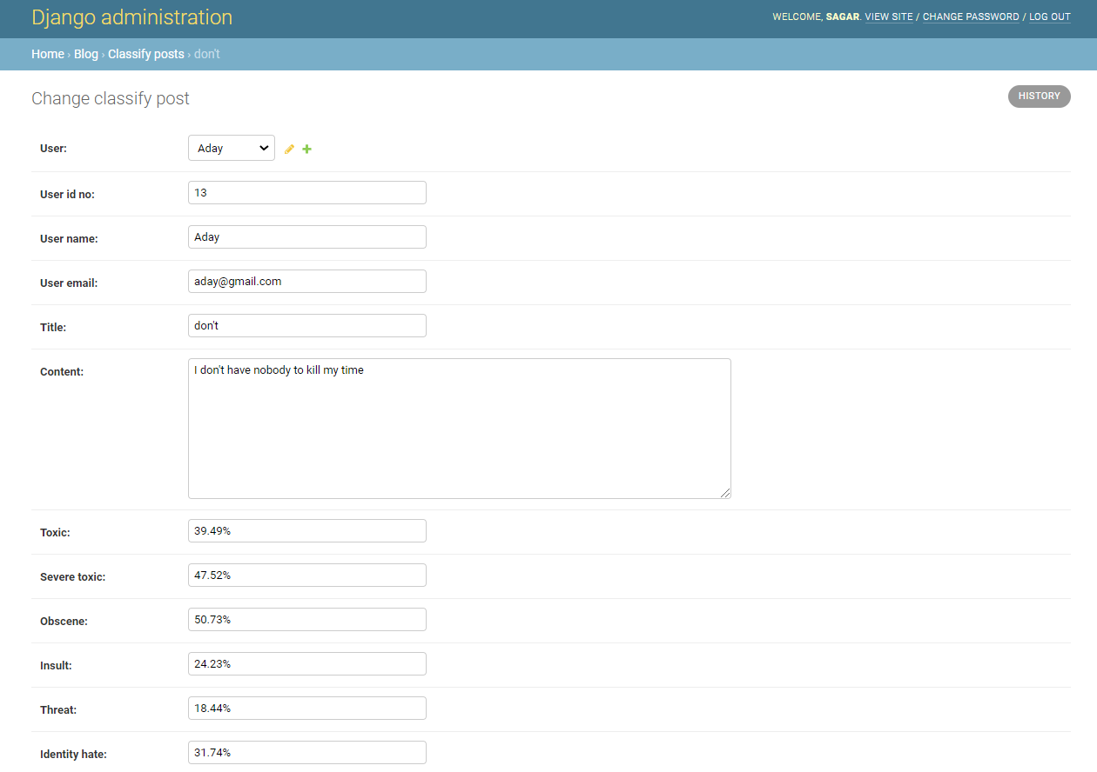

**Fig 7.1.7(a) Post Details Page**

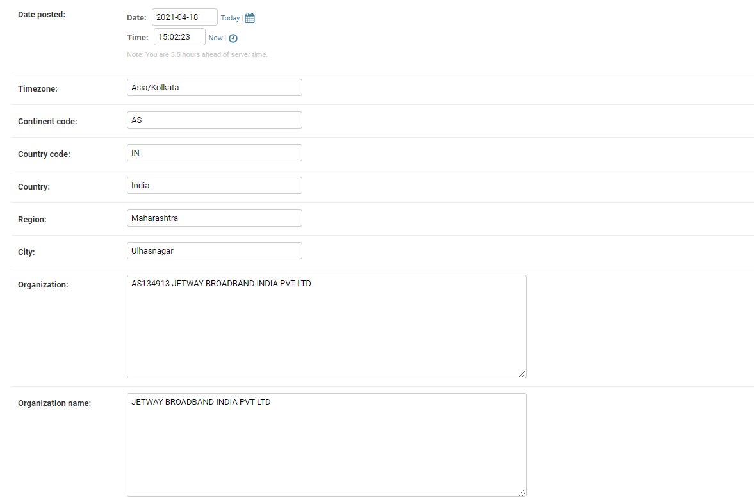

**Fig 7.1.7(b) Post Details Page**

7.1.8 Fake Account

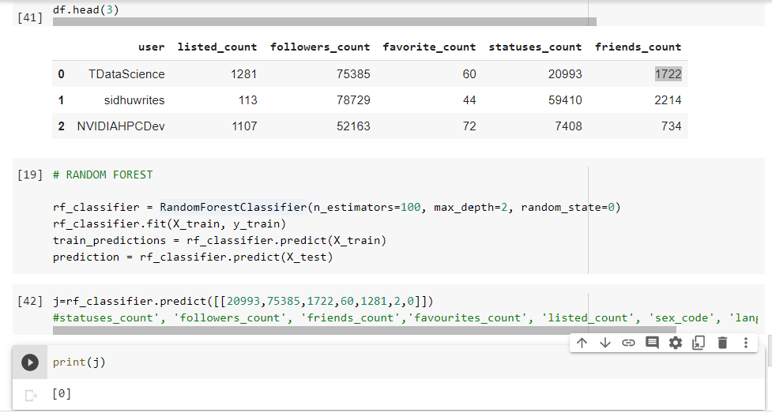

**Fig 7.1.8 Fake Account Page**

**7.2. Performance Evaluation measures**

**7.2.1 Analysis**

The F1 Score is the 2*((precision*recall)/(precision+recall)). It is also called the F Score or the F Measure. The F1 score conveys the balance between the precision and the recall so we had compared the F1 Scores of the Algorithms used.

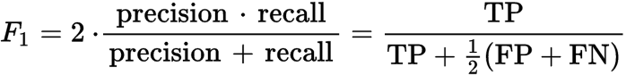

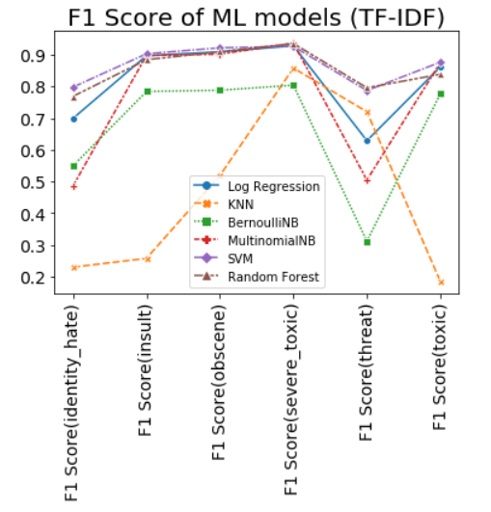

**Fig 7.2.1 Comparison of F1 Score of the different Algorithm in graph form**

**7.2.2 Performance Overview of Algorithm Used**

The Random Forest Algorithm is used to solve both regression and classification problems, making it a diverse model that is widely used by engineers.

When performing Random Forests based on classification data, you should know that you are often using the Gini index, or the formula used to decide how nodes on a decision tree branch

.

This formula uses the class and probability to determine the Gini of each branch on a node, determining which of the branches is more likely to occur. Here, *pi* represents the relative frequency of the class you are observing in the dataset and *c* represents the number of classes.

**7.3. Input Parameters / Features considered**

**7.3.1 Cyberbullying Dataset**

The Cyberbullying Dataset contains 7 parameters that is 1)comment_text 2)toxic 3)severe_toxic 4)obscene 5)threat 6)insult 7)identity_hate

1. comment_text - The following parameter contains the bad words or the bully words in each tuple and this column is processed using the Count Vectorizer Method which groups the similar words in to one so that if the similar kind of bully or bad words if used then can be recognized in the post
2. toxic - If the comment related to the cyberbully is toxic then the entry of the toxic parameter is set to ‘1’ else it will have value ‘0’
3. severe_toxic - This parameter will contain the value as ‘1’ i the commen_text to which it is related is severe_toxic else it will be by default ‘1’
4. obscene - Obscene parameter in this dataset with respect to its comment_text is set to ‘1’ if it is an obscene or else ‘0’
5. threat - A warning that somebody may hurt, kill or punish you related to the text if found in comment_text then it is ‘1’ or ‘0’
6. insult - This Parameter contain value as ‘1’ if found text related to it is found to be insult else ‘0’
7. identity_hate - It is set to ‘1’ if comment_text parameter to which it is related is found to be identity hate else it is set to ‘0’

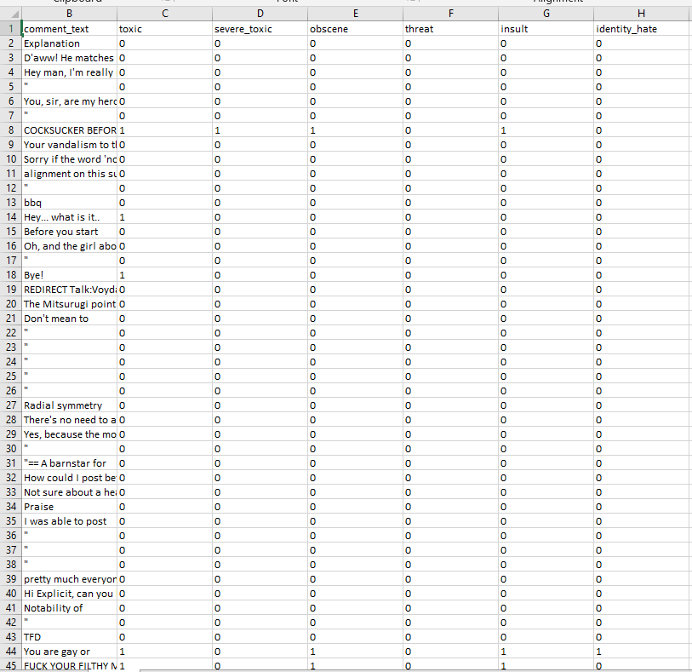

**Fig 7.3.1 Cyberbully Dataset**

**7.3.2 Fake Account Dataset**

The Fake Account Detection dataset has the following parameters i.e

1) Name - It has names of the account holders.

2) Status Count - Total Status updated by users.

3) Followers Count - It shows the number of people the account holder follows.

4) Friends Count - It shows the total number of friends count of users.

5) Url - The user profile's URL

6) Time Zone - It is the time zone.

7) Listed Count - It counts how many websites the user visits.

8)Screen Name - It is the display name of the user on the website.

9) Profile Bio - It describes the profile of the user on different social media.

10) Location - it identifies the current location from where the user is operating.

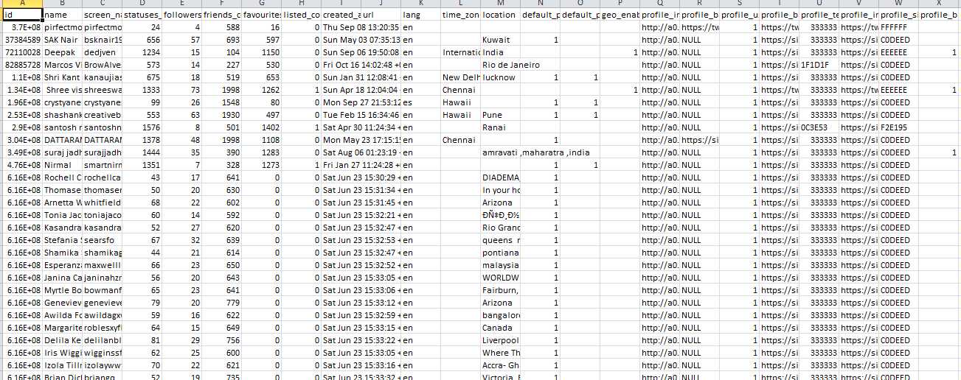

**Fig 7.3.2 Fake Account Dataset**

**7.4. Graphical and statistical output**

**7.4.1 Exploratory Data Analysis of comments based on different categories**

The below graph shows the comparison of the different categories of text or comment and their total values found in the dataset as compared to others.

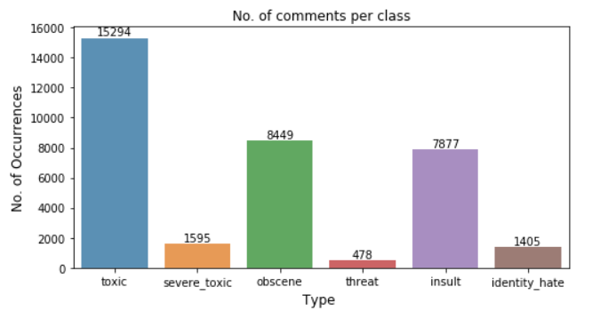

**Fig 7.4.1 Exploratory Data Analysis of comments based on different categories**

**7.4.2 Exploratory Data Analysis of comments based on different categories**

As shown below after applying the ML algorithms based on each category we had first compared the accuracies i.e F1 Score of the different algorithms and concluded that the Random Forest algorithm will give the best of all.

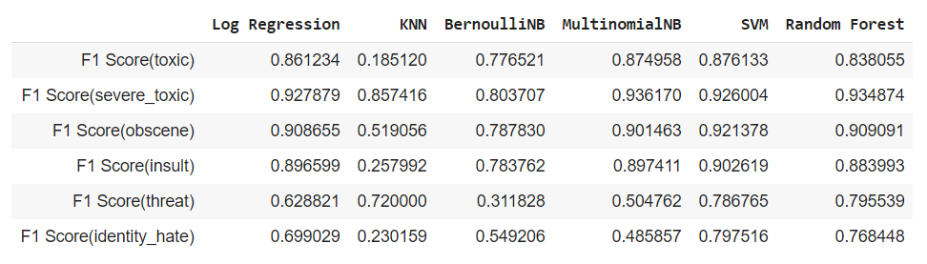

**Fig 7.4.2 Comparison of F1 Score of the different Algorithms**

**7.4.3 Accuracy Comparison for Fake Account**

In below diagram we had compare the accuracy of Decision Tree algorithm, Kernel SVM , Random Forest algorithm and as shown the Random Forest algorithm had given the best Accuracy

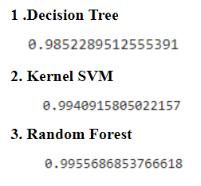

**Fig 7.4.3 Accuracy Comparison For Fake Account**

**7.5. Comparison of results with existing systems**

1] Lack of Security -There is a lack of Security in the existing systems but our system will deal with the proper security provision to the users.

2] No Transparency- As the existing system doesn’t provide the proper transparency in their system as they are not able to deal with the Sharing of their reports to the Cybercrime Department.

3] Costly to Produce Reports - The other systems will cost a lot to generate the reports but the system that we will develop will generate results and reports for free.

**7.6. Inference drawn**

Increase of Cyber Crime and Bullying at Social Networking Sites have increased nowadays so there is a Need for Detection and categorization of cyberbully and Removal of Fake Accounts so we had developed a website where we provide a Secure Environment for Users of any Age so that they can post any blog or comment they want but if that comment or text or post if found bully then we had applied the Machine Learning to remove the Cyber Crime and Bullying by first categorizing them and showing them to the Admin which can login to the admin panel and can review it and hence we had achieved Secure System Entry also Operations Layout which will be well Maintained. For the Fake account detection we had first trained our dataset and then we fetched the live data from twitter where we had tested whether the account is fake or not.

**CHAPTER – 8**

**CONCLUSION**

**8.1 Limitations**

* Intel Pentium Processor
* RAM>=4GB
* Anaconda
* Visual Studio
* Windows 10 SDK
* Continuous network connectivity required
* Process or requirement varies according to the Dataset

**8.2 Conclusion**

In this project, we proposed an approach to detect cyberbullying using machine learning techniques.

We have evaluated our model on Different ML Algorithms and we have also used Countvectorizer for features extraction By using machine learning algorithms to its full extent.We have evaluated our model on First Cyberbully by comparing accuracies of the different algorithms we can conclude that Random Forest gives us the best accuracy and from the model results evaluated on the Fake Account we found that the best accurate algorithm is Decision Tree having the accuracy of By using machine learning algorithms to its full extent, we have eliminated the need for manual prediction of a fake account, which needs a lot of human resources and is also a time-consuming process.

**8.3 Future Scope**

* To reduce the toxicity classification on the Double negative sentence

(For e.g “I don't have nobody to kill my time” )

* If a post contains a normal text and a web page link ,our system will identify the web link as the simple text and will calculate the percentage of all the categories.we can use a web crawling method to scrap the text from the web page and calculate the percentage of all the categories.
* Visual Cyberbullying is more harmful than the written ones thus we also plan to develop ML classifiers detecting cyberbullying from videos and images. This goal could be reached through the contribution of scholars from different fields, because of the technical (i.e., difficulty to create datasets containing this type of entries) and legal (i.e., privacy issues) issues raised by sharing multimedia content.
* It is also necessary to understand which impact these detection systems could have on users' everyday life. Future works will be challenged to combine these technological systems with the implementation of psychosocial interventions.
* We can Restrict the access of the fake account users to the authentication servers or the sites.

**CHAPTER – 9**

**REFERENCES**

**References (papers + books + Patent)**

[1] N. V. Chawla, K. W. Bowyer, L. O. Hall, and W. P. Kegelmeyer,“SMOTE:synthetic minority over-sampling technique,” Journal of Artificial Intelligence Research, vol. 16, pp. 321–357, 2002.View at: Google Scholar.

[2] I. Jolliffe, Principal Component Analysis, 2002.View at: MathSciNet.

[3] S. Sperandei, “Understanding logistic regression analysis,” Biochemia Medica, vol. 24, no. 1, pp. 12–18, 2014.View at: Publisher Site | Google Scholar.

[4] R. Kohavi, “A study of Cross-Validation and Bootstrap for Accuracy Estimation and Model

Selection,” in Proceedings of the in 14th international joint conference on Artificial intelligence,

pp. 20–25, 1995.View at: Google Scholar.

[5] J. W. Patchin and S. Hinduja, “Bullies Move Beyond the Schoolyard; a Preliminary Look at Cyberbullying,” Youth Violence and Juvenile.

[6] N. E. Willard, Cyberbullying and Cyberthreats: Responding to the Challenge of Online Social Aggression, Threats, and Distress.

[7] J. C. Platt, “Fast Training of Support Vector Machines using Sequential Minimal Optimization.

**CHAPTER – 10**

**APPENDIX**

**10 Appendix**

**1. Paper I Details**

1. **Paper published**

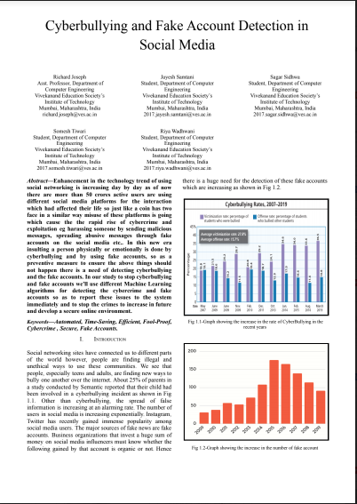

**Fig 10.1.1(a) IEEE Paper**

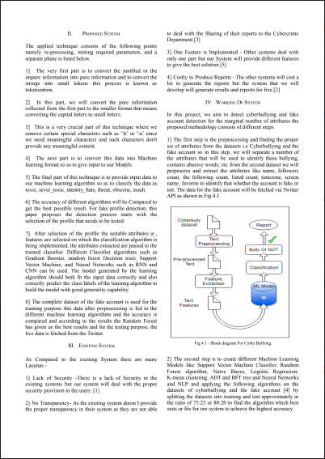

**Fig 10.1.1(b) IEEE Paper**

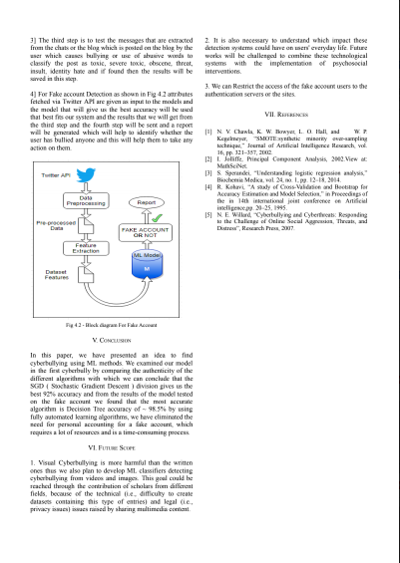

**Fig 10.1.1(c) IEEE Paper**

1. **Certificate of publication**



**Fig 10.1.2(a) ICAST Conference Certificate**



**Fig 10.1.2(b) ICAST Conference Certificate**



**Fig 10.1.2(c) ICAST Conference Certificate**



**Fig 10.1.2(d) ICAST Conference Certificate**



**Fig 10.1.2(e) ICAST Conference Certificate**

1. **Plagiarism report**

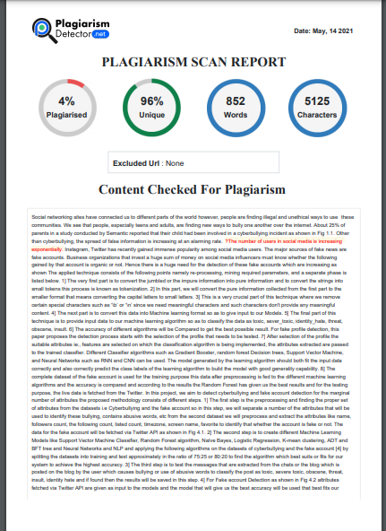

**Fig 10.1.3(a) Plagiarism Report**

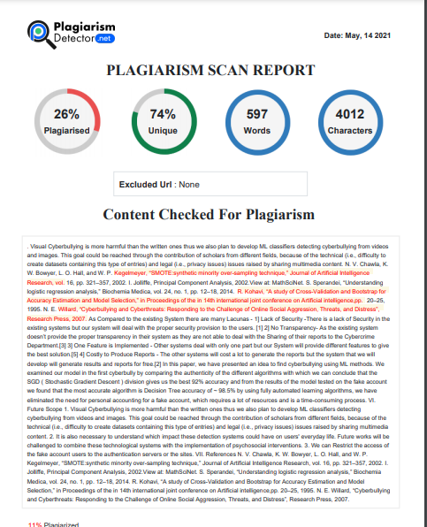

**Fig 10.1.3(b) Plagiarism Report**

1. **Project review sheet**

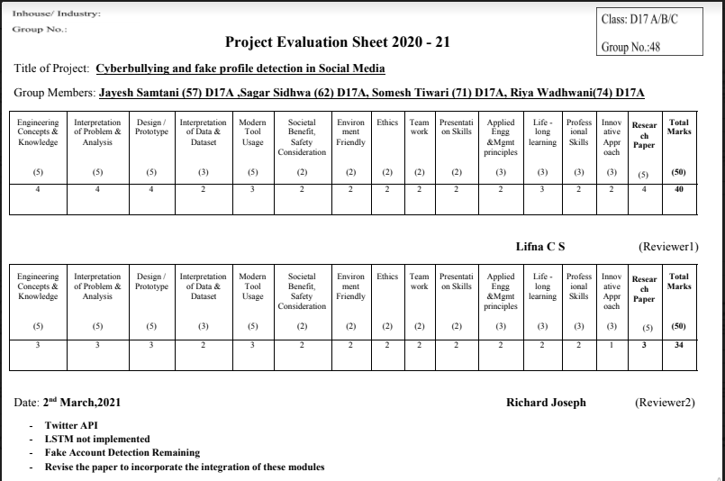

**Fig 10.1.4(a) Project Review Sheet-1**

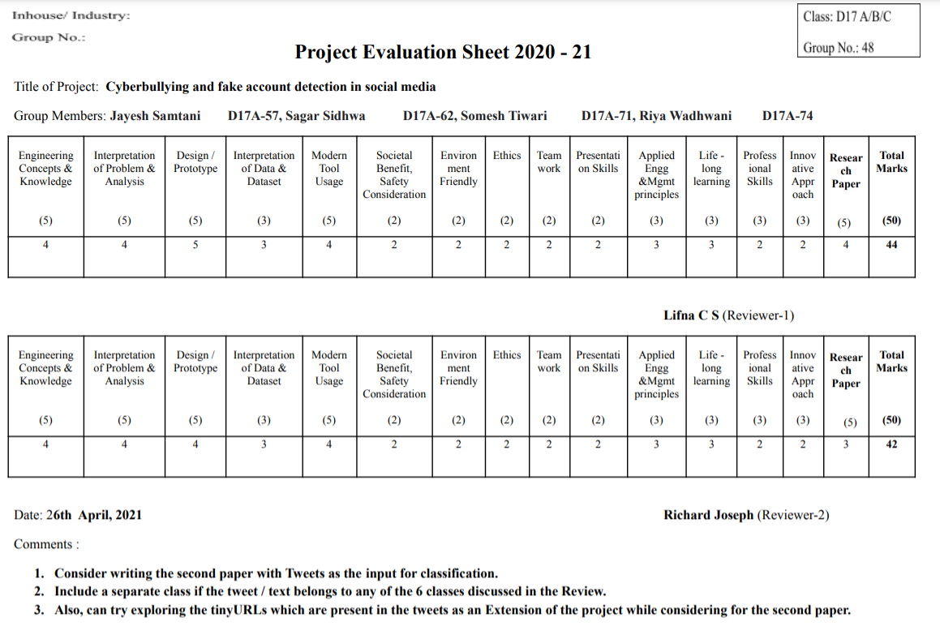

**Fig 10.1.4(b) Project Review Sheet-2**

**2. Video Presentation Link**

<https://drive.google.com/drive/folders/1aKjvB451-9hCupwt-0LNYT5CceBgy2s2?usp=sharing>